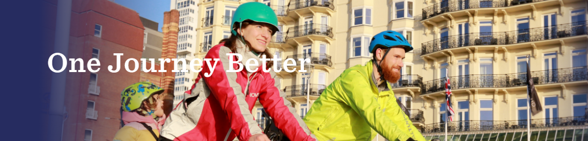

Dear Parents / Carers

Have your say – Changes to support active and sustainable travel in the city

We're seeing significant changes to the way people use the city’s streets. More of us are walking and cycling for exercise and to get to work, school and other destinations. Brighton & Hove City Council has therefore launched a consultation on changes planned for travel and transport in the city. Those proposals are designed to support active, inclusive and sustainable travel, including supporting children travelling to school, and are funded from the government’s Active Travel Fund.
Proposals are located in four areas of the city:
- Western Road
- Preston Circus to Patcham Roundabout (A23)
- Old Shoreham Road (A270) (both new and existing temporary changes)
- Seafront (A259) (both new and existing temporary changes)

This is a great opportunity to put your views forward around possible improvements that could help make your journey to school and beyond safer and more sustainable, bringing in other benefits such as contributing to cleaner air and better health for the whole family.
You will find attached further information on each of the proposals. More information can also be found at: www.brighton-hove.gov.uk/onejourneybetter . Via this link you will also be able to give your views through an online survey until 14 March 2021.
To request a paper copy of the information, together with a copy of the questionnaire, or to request information in an alternative format or language, please email transport.projects@brighton-hove.gov.uk or call 01273 293614 and leave a message with your request.
We look forward to hearing your views,
Kind regards

School Travel Team
Brighton and Hove City Council
