SITE MANAGER
FOR CENTRAL HUB BRIGHTON
Homewood College Site

Homewood College caters for children aged 11-16 who have social, emotional and mental health difficulties

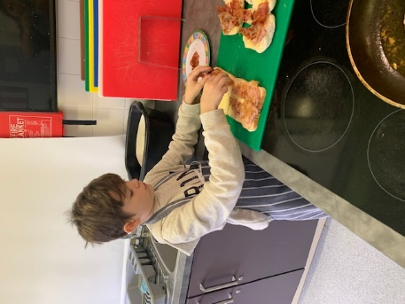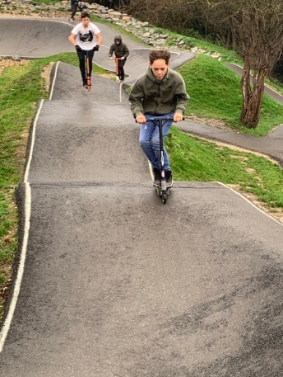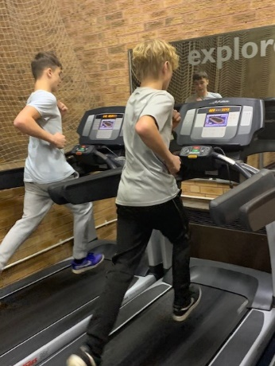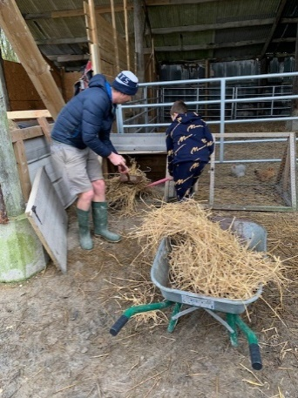

“A different kind of learning”
Our vision is to become a holistic hub where children are nurtured, inspired and engaged so that they can achieve to the best of their ability and lead happy and fulfilled lives.

Job Title: Site Manager – Central Hub Brighton
Homewood College site
Hours: 37 hours per week, 52 weeks per year
Contract Type: Permanent
Closing Date: 18th July 2021
Interview Date: 20th July 2021
Salary Band: Level D - £25,481 – £27,041 pro rata
Homewood College are looking for an enthusiastic Site Manager to work in our organisation. The post is full-time, 37 hours per week, Monday to Friday and hours of work are to be agreed with the successful candidate. We need someone who is hard-working, friendly and highly committed who will ensure that our learners and staff can work in a safe, clean and healthy environment. The successful candidate will be an important member of our school team and have a positive approach to this key role.
They will also need to be:
- Resilient, flexible, positive and able to travel across sites
- evidence the knowledge and skills referred to in the attached job description
- trained to drive or willing to train to drive a mini bus
- trained or willing to train as a Caretaker as necessary
We have an enthusiastic staff team and strive always to ensure our learners have access to the best possible educational experience in order that our students can overcome any barriers they have had to learning in the past. Central Hub Brighton is committed to safeguarding and promoting the welfare of children and young people and to equality of opportunity. We expect all staff and volunteers to share this commitment. Please note that this post is exempt from the Rehabilitation of Offenders Act 1974, and is subject to a Disclosure & Barring Service (DBS) Check. Central Hub Brighton are committed to the principles of Equality and carry out duties in accordance with the Council’s Inclusive Council Policy. For any other details please contact Sarah Parks – Tel: 01273 916595, Email: sarahparks@chb.org.uk or visit the website at http://www.chb.org.uk
Deadline for applications: 18th July 2021
Interview: 20th July 2021

June 2021

Dear Candidate

Thank you for your interest in becoming our Site Manager at Homewood College, part of Central Hub Brighton.

The school will have 50 students on roll in September, but is due to grow to 60 over the next few years. We will moving to a refurbished site in 2022.

Homewood was judged as ‘Requires Improvement’ in our last inspection, but the indicators were that we were very close to ‘Good’.

Many staff at Homewood have been here for a long time and describe it as their Homewood family. Relationships are key, and staff are skilled at developing these and helping students to feel included and wanted – Ofsted reported that “Pupils say they like the school because staff listen to them”. No two days are the same here and it is our passion to improve the lives of our students, and the variety of each day, that motivates us to come to work.

Homewood is a lively, often challenging, but rewarding place to work. Our students deserve the very best, and we are striving to improve as quickly as possible.

I hope you decide to apply for this role and I look forward to meeting you at interview.

Yours faithfully

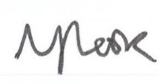

Louise Cook
Executive Headteacher

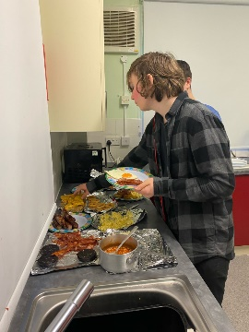
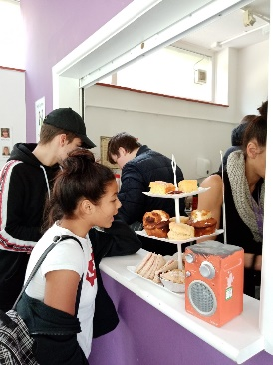

Important Information

School Visits
We warmly welcome potential applicants to visit the school. We would ask that you keep to our Covid requirements including wearing a face covering. To arrange a visit please contact a member of our school office team on 01273 916595 or email Sarahparks@chb.org.uk

Closing dates for applications – 18th July 2021

Please return your completed application form to: sarahparks@chb.org.uk

We are unable to accept applications via post or CVs.

Shortlisting of candidates and interviews

Emailed letters will be sent to shortlisted candidates by 19th July 2021 and your referees will then be sent a reference request. Interview date 20th July 21.

Salary and hours

The working pattern will be negotiated with the successful candidate; the post is 52 weeks per year. Salary scale 5 £25,481 – £27,041

Safeguarding

The governing body of Homewood College is committed to safeguarding and promoting the welfare of children and young people. In order to ensure this, our recruitment and selection policy is in accordance with both local and national guidance.

