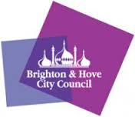

**Summer Holiday Consultation Line**

Dear Parents/Carers,

Do you have a child or young person at school in Brighton & Hove?

**If you have any concerns about their Emotional Mental Health and Wellbeing you are invited to talk to a Primary Mental Health Worker from the Schools Wellbeing Service.**

Telephone consultations are available over the Summer holiday.

***26th July – 3rd September***

***9am-12pm.***

**Please email** [**SWSConsultationLine@brighton-hove.gov.uk**](mailto:SWSConsultationLine@brighton-hove.gov.uk)

You will need to send us your name and phone number and a Primary Mental Health Worker will call you back.

Whilst we aim to call back within two days, please be aware we may have a high demand, so your patience is appreciated.

**This is not a crisis number – if you require immediate support you need to contact your GP, call CAMHS duty care on 03003040061 or go direct to A&E**

**For information on different services available, please visit findgetgive.com**