The Hive Newsletter
Spring 2
2022
The Hive
It’s great to see the Homewood spring daffodils emerging from their slumber. On the theme of growth, we are having more students busily working this term in The Hive.

This term one of our Year 9 students will be working towards a Level 1 maths qualification so we will be working closely to get him ready for this challenge.

We have been busy developing a programme that will enable the students to complete an industry standard Level 2 Certificate in Food Safety and Hygiene. This will be available to students studying the existing ASDAN Personal Development Programme in The Hive. We look forward to seeing lots of success in developing this essential skill. These guys will be a great asset to the new Homewood Pizzeria.

Congratulations to Eli who has been a fantastic attender of The Hive and has attended 100% of all face to face and online sessions.
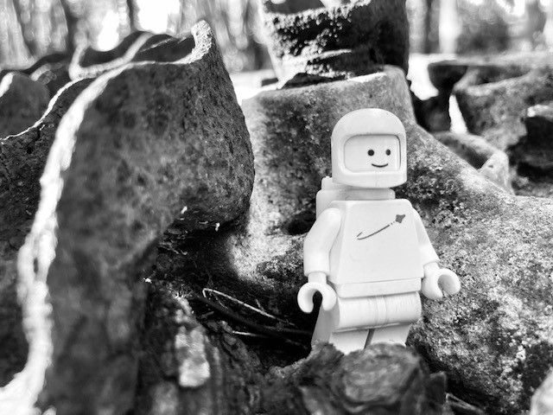

An example of ‘Legography’ (Lego Photography), on a local excursion.

A weekly PSHE programme has been introduced which will help the students understand their rights and responsibilities in all types of relationships. This will be support DfE requirements to teach British Values.

