Year 7 Newsletter
Spring 2
2022
Year 7
Since half term, we have made some exciting new improvements to Year 7. We are developing the new classroom with the items and ideas put forward by the students.

This term we are continuing to learn about Space. As part of our topic, we will be tasting astronaut space food, learning about the planets, delving into the incredible world of space travel and we also plan to go on some exciting trips to explore the topic further.

Mobile Phones
Thank you for your continued support with mobile phones.

Year 7 have been setting the standards for handing in mobile phones with an almost perfect 100% record since the new year!

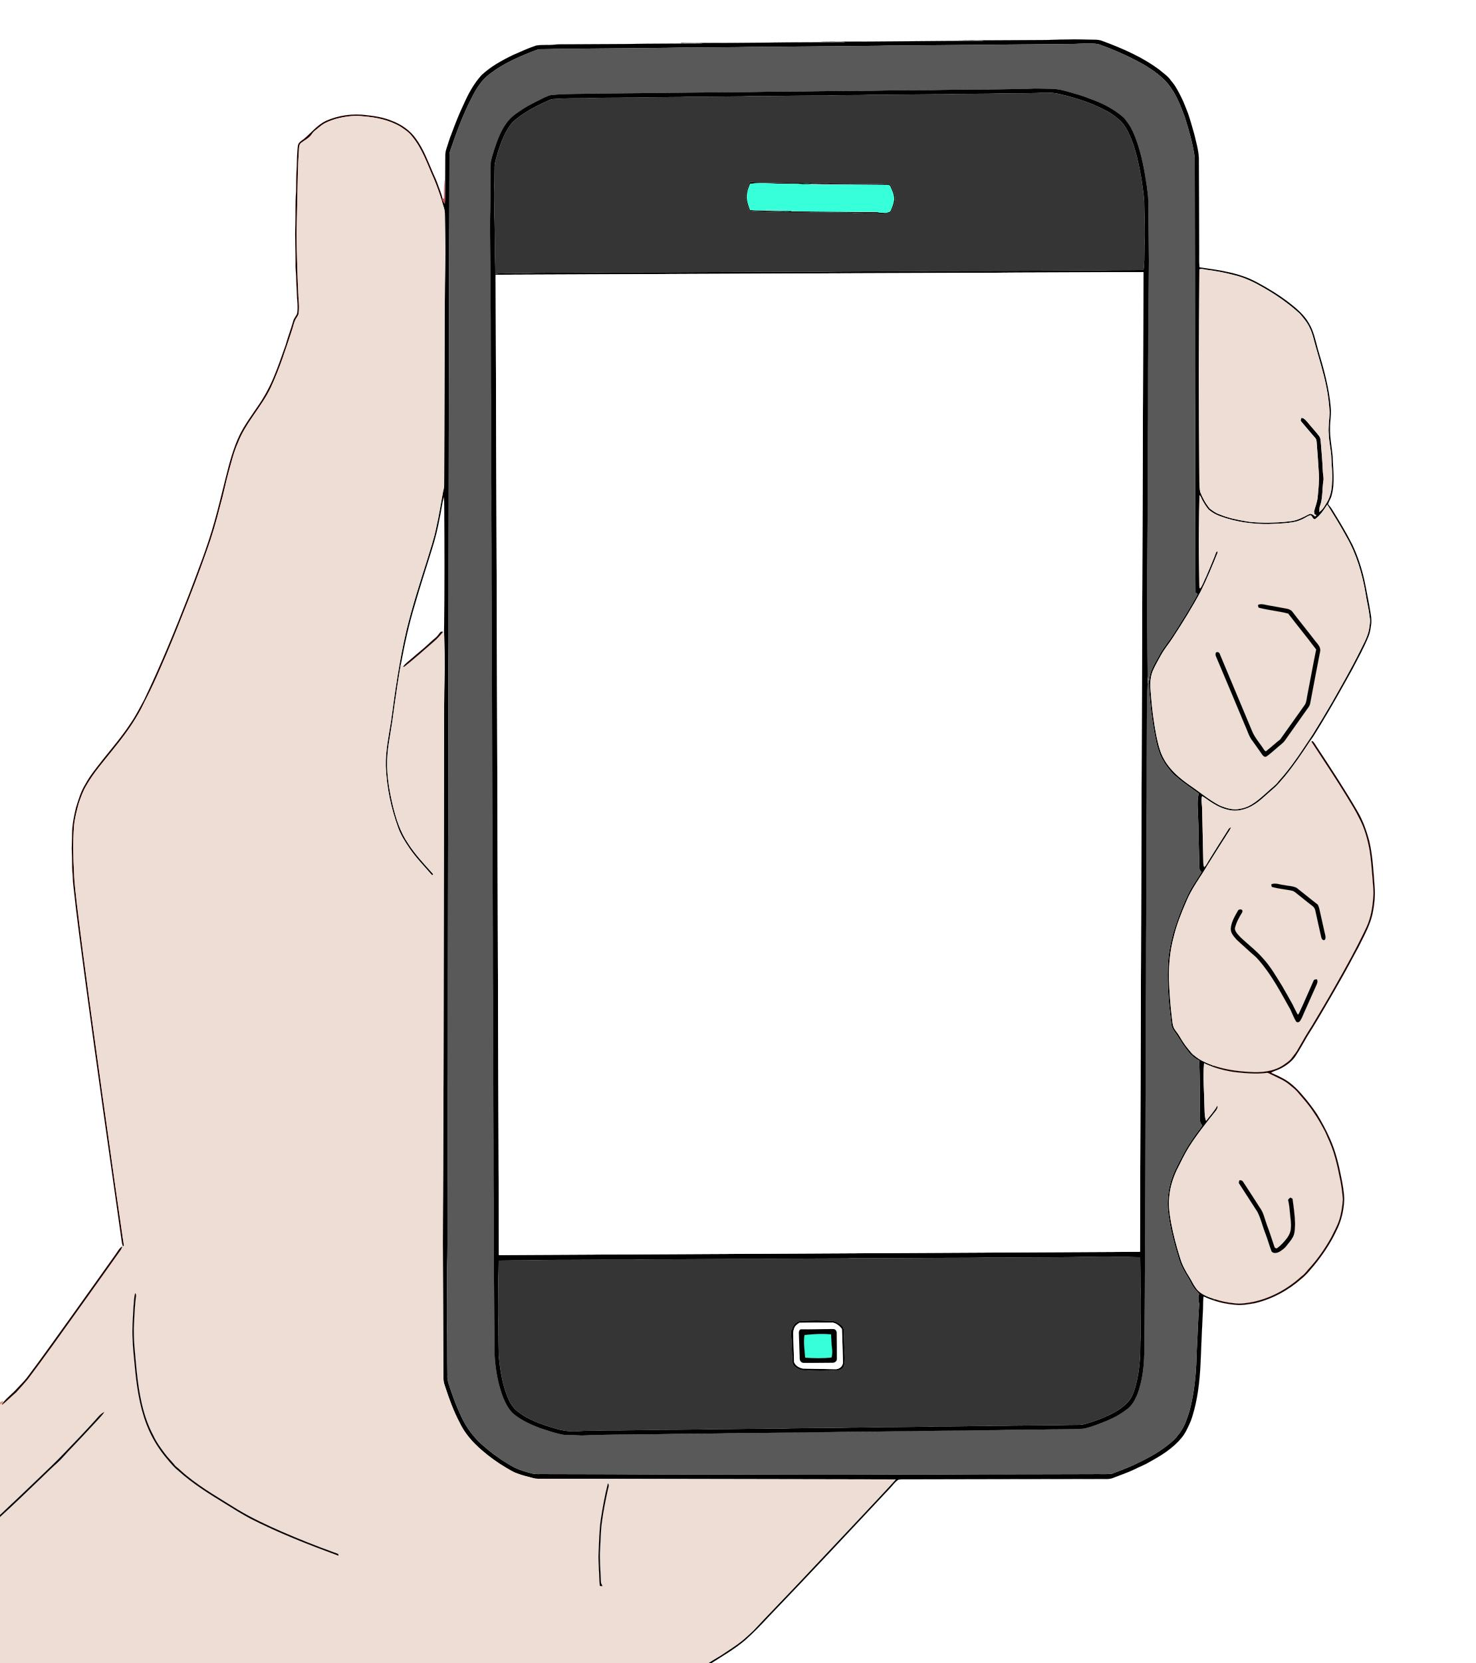

Class Dojo
We have launched Class Dojo with
Year 7.

Log in details have been emailed home where you, as parents, can connect with your child's account. This will give you access to a school and class newsfeed with pictures, videos and information keeping you up to date with all the creative things the children are doing at school. Please check your emails for a class Dojo email.

Homewood Pizzeria
Well done and thank you to the Year 7s for decorating the canteen ready for the Homewood Pizzeria launch. It was a great success and made even better with your creative interior design 😊

