**Year 9 Newsletter**

**Spring 2**

**2022**

**Our main focus for SEMH**

As a group we are focusing on how other people are thinking.

When is it important to care about what people think of us and when should it not matter? This is a tough thing to work out and we are trying to practise this skill by focusing on the things we do.

We are trying to ask ourselves why we change what we do because of what we think other people are thinking.



Our terrariums are teaching us about the rainforest and the water cycle. We have kept them alive since the start of term and hope we can keep them alive until the end.

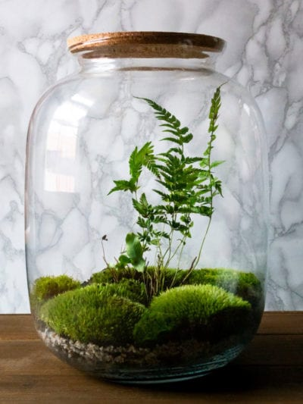

**Year 9**

In Maths we are learning about angles, shapes and transformations. We have been writing openings to stories in English, trying to make them as exciting as possible. PE this term is mainly swimming but we have been doing some PE at school as well.

We have started computer programming for the first time this year. This started with working out how to make a cup of tea but we will be finding out how difficult it is to get a robot to do it properly.

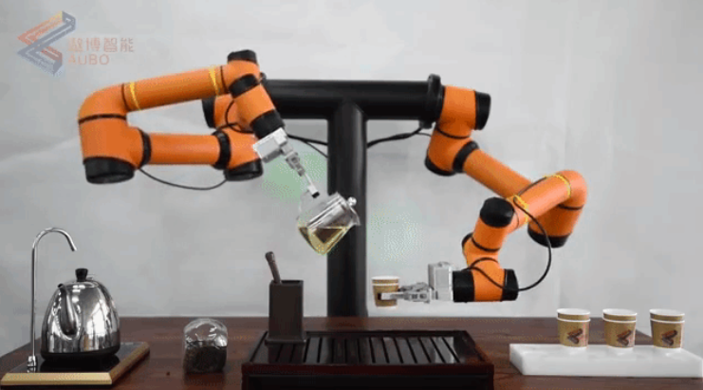

**Points**

So far the Year 9 group are averaging a silver award every week but are very close to a gold award overall. If we can earn as many points as possible we think we might get our Gold Trip at the end of term.

The Year 9s have started Natural Art, looking at the work of Andy Goldsworthy. Well done to Codie for creating a driftwood and stone sculpture. Andy Goldsworthy artwork is supposed to be very temporary, it either blows away or melts. Codie's art work will last for ever given the amount of glue on it!